NAME:Rishik JK
REG.NO :192511052

CSA1702-ARTIFICIAL INTELLIGENCE
LAB EXPERIMENT

29. Prolog Program for Forward Chaining

1. Aim
To write a Prolog program to implement forward chaining using facts and rules to derive new information.

2. Algorithm
- Start the program.
- Define the initial facts.
- Define rules based on the facts.
- Check the available facts.
- Apply rules to derive new facts.
- Display the derived conclusion.
- Stop.
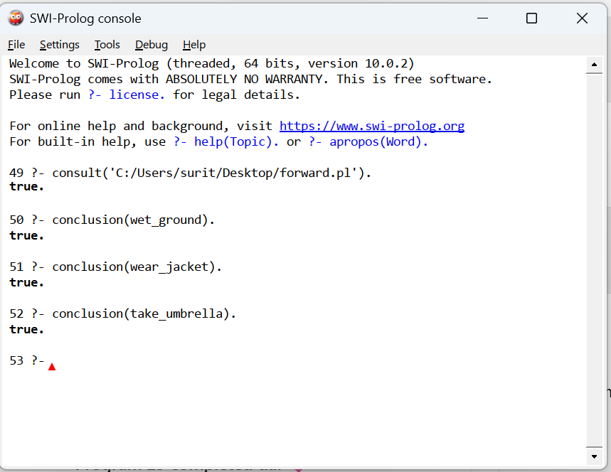

3. Result
Thus, the Prolog program to implement forward chaining using facts and rules was successfully implemented and executed. New conclusions were derived from the existing facts.

9

